|  |  |
| --- | --- |
| Lab | 7 |
| Student No | 16725829 |
| Registered Programme | DN201 Data Science |
| Date |  |

**Exercise 1**

A brewery that owns a chain of bars/restaurants throughout Ireland needs to assess the suitability of new sites for the establishment of a new premises. When classifying a potential site as suitable/unsuitable it examines a number of attributes about the area where the site is located. These attributes describe whether the site is a city or a large town, whether a university is located in the area, what type of housing estate, if any, is nearby, etc. For each attribute there are a number of attribute values, for example {Y=yes, N=no} for City, {M=medium, S=small, N=none, L=large} for Housing-Estate. A subset of the brewery database is listed below where each existing bar/restaurant is given a class label. Here +(positive) means that the brewery consider the site to be successful and –(negative) means that the site is borderline and they would not wish to make a similar investment in the future. The brewery wish to use the database to find a set of rules that will help them decide on the suitability of a new potential site

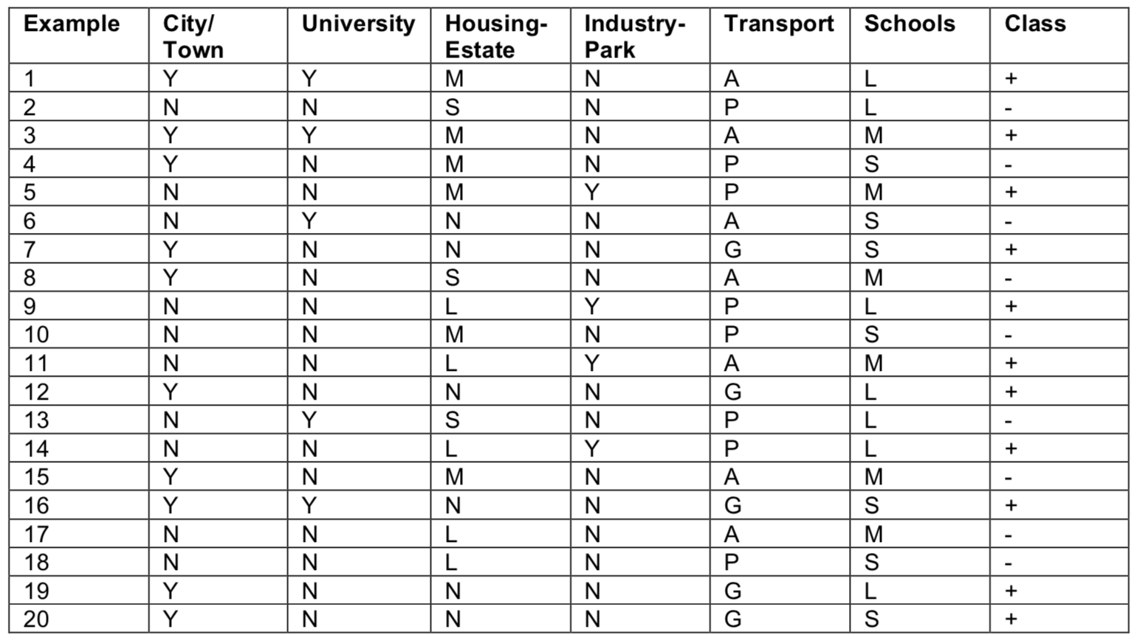

In the following steps, work out the full decision tree for this problem by filling in the missing values in the white boxes. All numerical answers should be rounded to 3 decimal places.

1. By filling out the following table, calculate which attribute would be selected for expansion under the **root node**:

|  |  |  |  |  |  |  |
| --- | --- | --- | --- | --- | --- | --- |
| Id | Attribute | Value | Expanding Root Node (Level 0) | | | |
|  |  |  | H(Y) | H(Y|X=x) | P(X) | I(Y;X) |
| 0 | ROOT NODE |  | 0.993 |  |  |  |
| 1 | City/Town | N |  | 0.971 | 10/20 | 0.067 |
| 2 | City/Town | Y | 0.881 | 10/20 |
| 3 | University | N |  | 0.996 | 15/20 | 0.003 |
| 4 | University | Y | 0.971 | 5/20 |
| 5 | Housing-Estate | L |  | 0.971 | 5/20 | 0.255 |
| 6 | Housing-Estate | M | 1.000 | 6/20 |
| 7 | Housing-Estate | N | 0.650 | 6/20 |
| 8 | Housing-Estate | S | 0.000 | 3/20 |
| 9 | Industry-Park | N |  | 0.988 | 16/20 | 0.203 |
| 10 | Industry-Park | Y | 0.000 | 4/20 |
| 11 | Transport | A |  | 0.985 | 7/20 | 0.266 |
| 12 | Transport | G | 0.000 | 5/20 |
| 13 | Transport | P | 0.954 | 8/20 |
| 14 | Schools | L |  | 0.863 | 7/20 | 0.046 |
| 15 | Schools | M | 1.000 | 6/20 |
| 16 | Schools | S | 0.985 | 7/20 |

1. Starting from the **first node in level 1**, beneath the root node, fill out the following table to determine which attribute would be selected for expansion under that node:

|  |  |  |  |  |  |  |
| --- | --- | --- | --- | --- | --- | --- |
| Id | Attribute | Value | Expanding First Node Level 1 | | | |
|  |  |  | H(Y) | H(Y|X=x) | P(X) | I(Y;X) |
| 0 | ROOT NODE |  |  |  |  |  |
| 1 | City/Town | N |  | 0.918 | 3/7 | -0.007 |
| 2 | City/Town | Y | 1.000 | 4/7 |
| 3 | University | N |  | 0.811 | 4/7 | 0.128 |
| 4 | University | Y | 0.918 | 3/7 |
| 5 | Housing-Estate | L |  | 1.000 | 2/7 | 0.278 |
| 6 | Housing-Estate | M | 0.918 | 3/7 |
| 7 | Housing-Estate | N | 0.000 | 1/7 |
| 8 | Housing-Estate | S | 0.000 | 1/7 |
| 9 | Industry-Park | N |  | 0.918 | 6/7 | 0.198 |
| 10 | Industry-Park | Y | 0.000 | 1/7 |
| 11 | Transport | A | 0.985 |  | 1.000 |  |
| 12 | Transport | G |  | 0.000 |
| 13 | Transport | P |  | 0.000 |
| 14 | Schools | L |  | 0.000 | 1/7 | 0.291 |
| 15 | Schools | M | 0.971 | 5/7 |
| 16 | Schools | S | 0.000 | 1/7 |

1. Starting from the **first node in level 2**, beneath the node expanded at step b), fill out the following table to determine which attribute would be selected for expansion under that node:

|  |  |  |  |  |  |  |
| --- | --- | --- | --- | --- | --- | --- |
| Id | Attribute | Value | Expanding First Node Level 2 | | | |
|  |  |  | H(Y) | H(Y|X=x) | P(X) | I(Y;X) |
| 0 | ROOT NODE |  |  |  |  |  |
| 1 | City/Town | N |  | 0.971 | 5/5 | 0.029 |
| 2 | City/Town | Y | 0.000 | 0/5 |
| 3 | University | N |  | 0.971 | 5/5 | 0.029 |
| 4 | University | Y | 0.000 | 0/5 |
| 5 | Housing-Estate | L | 1.000 |  | 1.00 |  |
| 6 | Housing-Estate | M |  | 0.00 |
| 7 | Housing-Estate | N |  | 0.00 |
| 8 | Housing-Estate | S |  | 0.00 |
| 9 | Industry-Park | N |  | 0.000 | 2/5 | 0 |
| 10 | Industry-Park | Y | 0.000 | 3/5 |
| 11 | Transport | A |  |  |  |  |
| 12 | Transport | G |  |  |
| 13 | Transport | P |  |  |
| 14 | Schools | L |  | 0.000 | 2/5 | 1 |
| 15 | Schools | M | 1 | 2/5 |
| 16 | Schools | S | 0.000 | 1/5 |

1. Starting from the **second node in level 2**, beneath the node expanded at step b), fill out the following table to determine which attribute would be selected for expansion under that node:

|  |  |  |  |  |  |  |
| --- | --- | --- | --- | --- | --- | --- |
| Id | Attribute | Value | Expanding Second Node Level 2 | | | |
|  |  |  | H(Y) | H(Y|X=x) | P(X) | I(Y;X) |
| 0 | ROOT NODE |  |  |  |  |  |
| 1 | City/Town | N |  | 1 | 2/6 | -0.0148 |
| 2 | City/Town | Y | 1 | 4/6 |
| 3 | University | N |  | 0.811 | 4/6 | 0.444 |
| 4 | University | Y | 0 | 2/6 |
| 5 | Housing-Estate | L | 0.9852 |  | 0.00 |  |
| 6 | Housing-Estate | M |  | 1.00 |
| 7 | Housing-Estate | N |  | 0.00 |
| 8 | Housing-Estate | S |  | 0.00 |
| 9 | Industry-Park | N |  | 0.971 | 5/6 | 0.176 |
| 10 | Industry-Park | Y | 0 | 1/6 |
| 11 | Transport | A |  |  |  |  |
| 12 | Transport | G |  |  |
| 13 | Transport | P |  |  |
| 14 | Schools | L |  | 0 | 1/6 | 0.526 |
| 15 | Schools | M | 0.918 | 3/6 |
| 16 | Schools | S | 0 | 2/6 |

1. Starting from the **third node in** **level 1**, beneath the root node, fill out the following table to determine which attribute would be selected for expansion under that node: (why does the second node on level 1 not need to be expanded?)

|  |  |  |  |  |  |  |
| --- | --- | --- | --- | --- | --- | --- |
| Id | Attribute | Value | Expanding Third Node Level 1 | | | |
|  |  |  | H(Y) | H(Y|X=x) | P(X) | I(Y;X) |
| 0 | ROOT NODE |  |  |  |  |  |
| 1 | City/Town | N |  | 0.985 | 7/8 | 0.092 |
| 2 | City/Town | Y | 0 | 1/8 |
| 3 | University | N |  | 0.985 | 7/8 | 0.952 |
| 4 | University | Y | 0 | 1/8 |
| 5 | Housing-Estate | L |  | 0.918 | 3/8 | 0.2655 |
| 6 | Housing-Estate | M | 0.918 | 3/8 |
| 7 | Housing-Estate | N | 0 | 0/8 |
| 8 | Housing-Estate | S | 0 | 2/8 |
| 9 | Industry-Park | N |  | 0 | 5/8 | 0.954 |
| 10 | Industry-Park | Y | 0 | 3/8 |
| 11 | Transport | A | 0.954 |  | 0.00 |  |
| 12 | Transport | G |  | 0.00 |
| 13 | Transport | P |  | 1.00 |
| 14 | Schools | L |  | 1 | 4/8 | 0.454 |
| 15 | Schools | M | 0 | 1/8 |
| 16 | Schools | S | 0 | 3/8 |

1. Finally arrive at the decision tree. Each node in the tree corresponds to a particular attribute and value. Fill in the appropriate attribute and value for each node.

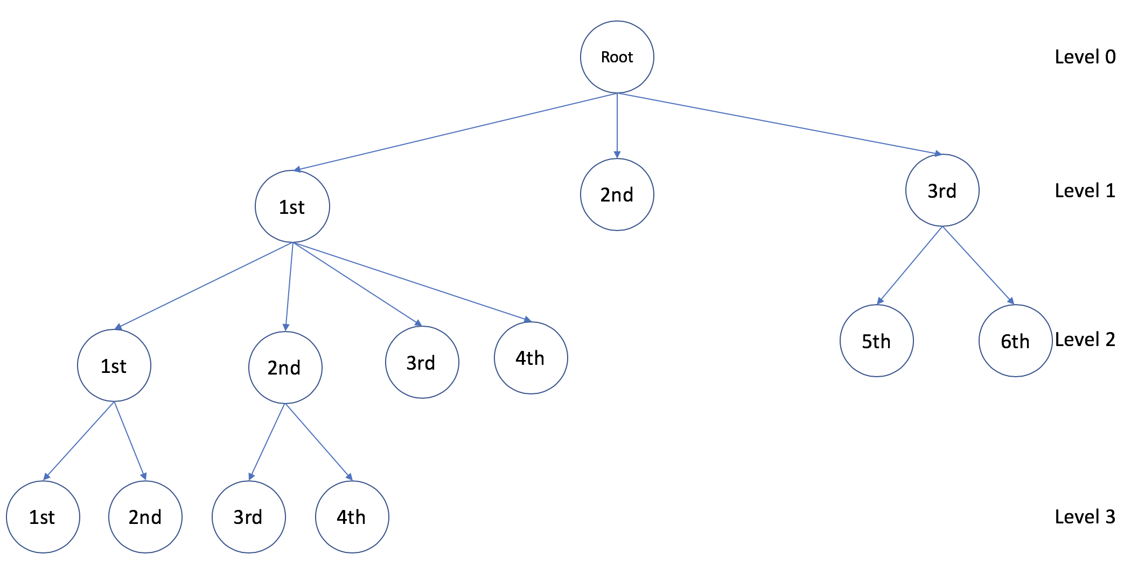

1. Using the decision tree, decide whether the following sites would be considered suitable:

|  |  |  |  |  |  |  |  |
| --- | --- | --- | --- | --- | --- | --- | --- |
| **Test Site** | **City/Town** | **University** | **Housing-Estate** | **Industry-Park** | **Transport** | **Schools** | **Decision** |
| i) | N | Y | N | N | P | L | + |
| ii) | Y | N | S | Y | G | S | - |
| iii) | Y | Y | S | N | A | S | - |

**Input your answers into the Moodle Quiz associated with this Lab.**